COMMON COURSE ASSIGNMENT FORMAT
ASSIGNMENT PROBLEM / CHALLENGE: E-Commerce Data Warehouse and Customer Churn Prediction

A. Assignment Information
Department | CSE
Programme | Regular
Course Code & Course Name | CSA1613 – Data Warehousing and Data Mining
Academic Year / Batch | 2024
Faculty Name | Dr. K.V. Kanimozhi
Assignment Title | Design and Development of an Integrated Data Warehouse and Data Mining System for E-Commerce Data Warehouse and Customer Churn Prediction
Date of Issue | 31/08/2026
Date of Submission | 02/09/2026
Maximum Marks | 100
Course Outcome(s) – CO | CO1: Design suitable data warehouse architectures and dimensional models that support effective decision-making.  CO2: Apply data preprocessing methods such as cleaning, integration, transformation and reduction to prepare reliable data.  CO3: Assess classification techniques on practical data to predict outcomes accurately and support informed decisions.
Bloom's Taxonomy Level | L3 – Apply; L4 – Analyze; L5 – Evaluate; L6 – Create
SDG Mapping | SDG 8 – Decent Work and Economic Growth; SDG 9 – Industry, Innovation and Infrastructure; SDG 12 – Responsible Consumption and Production
Industry / Societal Relevance | An integrated e-commerce data warehouse can help organizations understand customer purchasing patterns, recognize valuable customers and make better customer-retention decisions.

B. Assignment Problem / Challenge
E-commerce businesses generate large amounts of information from customer accounts, orders, products, payments, deliveries and online interactions. These records are often stored in different operational systems and may use different formats, names, structures and levels of detail. Because of this, management needs a centralized analytical environment that can combine the information and turn it into useful business knowledge.
The organization needs to study customer purchasing behavior, measure product and regional performance, identify valuable customers, group customers into meaningful segments, understand seasonal sales trends and predict which customers may stop purchasing. Customer churn represents a reduction in customer engagement or a complete stop in purchasing activity. Early identification of churn can help the organization take suitable retention actions.
The assignment therefore requires students to design, implement, analyze and evaluate an integrated Data Warehousing and Data Mining solution. The solution should combine ETL processing, dimensional modeling, OLAP analysis, data preprocessing and classification models such as Decision Tree, Naïve Bayes and Support Vector Machine.

C. Problem Statement
The e-commerce company generates large amounts of data from customers, orders, products, payments, deliveries and website interactions. However, this data is stored across different operational systems, making it difficult to obtain a unified view of customer behavior and overall business performance.
The company needs an integrated Data Warehouse and Data Mining solution that can collect, clean and transform data from multiple sources and store it in a suitable Star or Snowflake Schema. The system should support OLAP analysis to identify high-selling products, customer segments, seasonal sales patterns, regional performance and high-value customers.
In addition, the company needs to identify customers who are likely to stop using its services. Therefore, suitable machine learning algorithms such as Decision Tree, Naïve Bayes and SVM must be developed and compared to predict customer churn.
The proposed system aims to provide accurate business insights and churn predictions while considering customer privacy, fairness and ethical issues in customer profiling. The final solution will help management make better decisions, improve customer retention and increase overall business performance.

D. Requirements and Constraints
- Identify the operational data sources and clearly describe their entities, attributes and relationships.
- Combine customer, order, product, payment, delivery and interaction data through common identifiers and clearly documented matching rules.
- Create and justify a Star Schema or Snowflake Schema by defining fact tables, dimension tables, keys, measures and hierarchies.
- Develop a repeatable ETL workflow covering extraction, transformation, cleaning, integration, validation, loading and process logging.
- Prepare the data by handling missing values, duplicates, inconsistent records, outliers, transformations, reduction and discretization where necessary.
- Perform Roll-up, Drill-down, Slice, Dice and Pivot operations and explain the business meaning of each result.
- Analyze high-selling products, customer segments, seasonal trends, regional performance and high-value customers.
- Develop and compare Decision Tree, Naïve Bayes and SVM models for customer churn prediction.
- Evaluate the models using Confusion Matrix, Accuracy, Precision, Recall, F1-score and Cross-validation.
- Suggest customer-retention strategies based on the analytical and prediction results.
- Address privacy, fairness, transparency, possible bias, consent and responsible use of customer information.
- Clearly record assumptions, limitations, reproducibility requirements and computational constraints.

E. Student Work

1. Problem Understanding and Formulation
The proposed project focuses on developing an E-Commerce Data Warehouse and Customer Churn Prediction System. The e-commerce company collects large amounts of data from different sources, including customer details, orders, products, payments, deliveries and website interactions. Since this information is stored in different operational databases, it is difficult for management to obtain a complete view of customer behavior and business performance.
The main problem is to integrate these different data sources into a centralized data warehouse and analyze the information to support better business decisions. The system should identify important patterns such as high-selling products, high-value customers, customer segments, seasonal sales trends and regional performance.
Another major objective is to identify customers who are likely to stop purchasing or discontinue using the e-commerce service, known as customer churn. Machine learning classification algorithms such as Decision Tree, Naïve Bayes and Support Vector Machine (SVM) can be applied to customer data to predict churn.

2. Application of Course Knowledge

- This project applies the concepts learned in Data Warehousing and Data Mining to a real-world e-commerce problem. The knowledge gained from the course is used to integrate, process, analyze and mine large volumes of customer and business data.
- Data Warehousing: Used to create a centralized repository for customer, order, product, payment, delivery and interaction data.
- Dimensional Modeling: Applied Star/Snowflake Schema concepts using fact and dimension tables.
- ETL: Used the Extract, Transform and Load process to collect data from multiple sources, clean it and load it into the data warehouse.
- Data Preprocessing: Applied techniques such as handling missing values, removing duplicate records, data transformation and categorical data encoding.
- OLAP: Applied Roll-up, Drill-down, Slice, Dice and Pivot operations to analyze sales and customer information from different perspectives.
- Data Mining: Used data mining techniques to discover customer purchasing patterns, customer segments and high-value customers.
- Classification: Applied Decision Tree, Naïve Bayes and SVM algorithms to predict customer churn.
- Model Evaluation: Used metrics such as accuracy, precision, recall and F1-score to compare the performance of the classification models.
- Business Intelligence: Converted analytical results into useful information for improving sales, customer satisfaction and retention.
- Ethical Data Usage: Applied knowledge of privacy, fairness and responsible data handling while performing customer profiling.

3. Solution / Design / Methodology
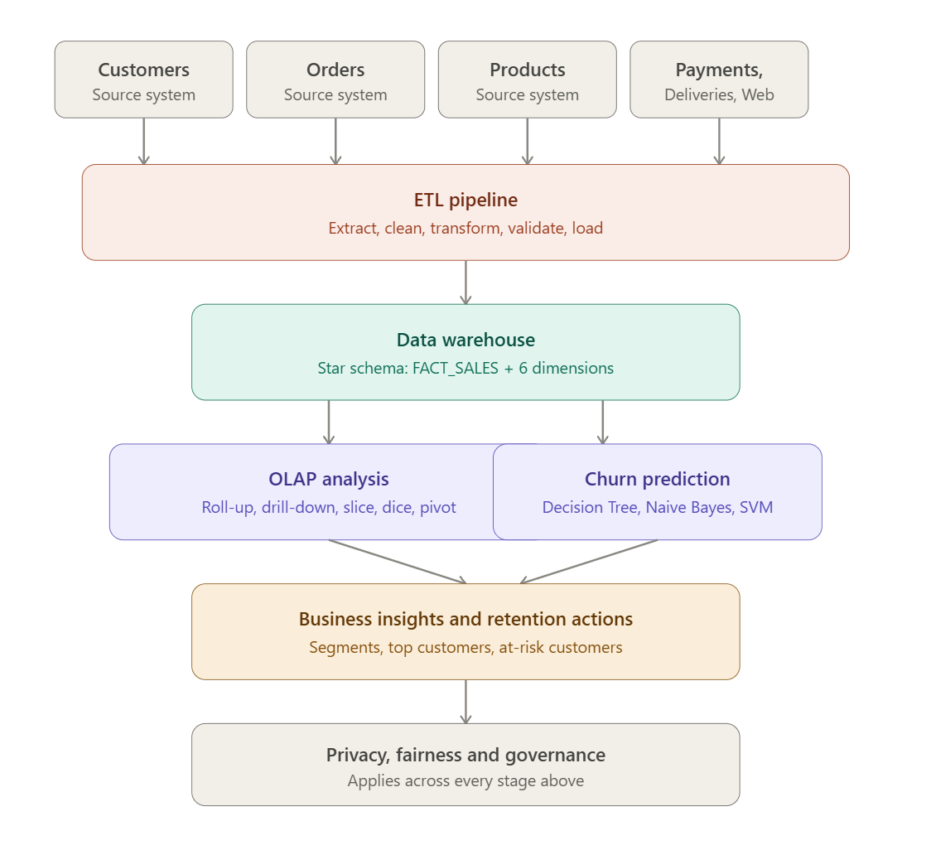
The project should begin by identifying the data sources and preparing a detailed data dictionary. Integration rules and reliable business keys should be established before designing the warehouse. The selected Star or Snowflake Schema should be explained and justified.
The grain of every fact table should be defined clearly, and decisions concerning normalization or denormalization should be explained. The ETL workflow should include validation and reproducibility, and historical information should be retained to support trend analysis.
Customer-level features should be created without using information from the future. The three churn models should be trained, tested and compared, and the final model should be selected using both performance results and business considerations.

4. Use of Modern Tools
Python can be used for data preprocessing, ETL activities, analysis and machine learning. Libraries such as Pandas, NumPy, Scikit-learn and Matplotlib may be used where appropriate. SQL or another suitable database platform should support the warehouse implementation.
Git and GitHub should be used for source-code management and version control. Screenshots and execution evidence should be included to demonstrate the use of the selected tools.

5. Results and Validation
The project should present ETL validation evidence, including record counts, missing-value checks, duplicate checks, referential-integrity checks and acceptable value ranges. The implemented warehouse schema should be presented along with its output.
The five OLAP operations should be demonstrated with clear interpretations. Tables and graphs should be used to present findings related to products, customers, seasons, regions and high-value customers. For all three classification models, Confusion Matrix, Accuracy, Precision, Recall, F1-score and Cross-validation results should be reported.
The final validation should confirm whether the developed solution satisfies the requirements stated in the assignment.

6. Analysis and Engineering Decision
The analytical results should be interpreted rather than simply displayed. Decision Tree, Naïve Bayes and SVM should be compared according to their strengths, limitations, interpretability and computational requirements.
False positives and false negatives should be discussed in terms of their possible business effects. The selected model should be justified using both quantitative evidence, such as evaluation scores, and qualitative evidence, such as interpretability and practical usefulness. Trade-offs among accuracy, complexity and deployment requirements should also be considered.

7. Broader Considerations
The project should explain how customer information can be protected and handled responsibly. This includes secure access, appropriate storage, controlled sharing and data minimization.
Students should consider whether customer profiling may introduce unfairness or bias and should explain how such risks can be assessed. The transparency of automated churn predictions should also be discussed, including the fact that predictions are probabilistic and may be incorrect. The work should be connected to SDG 8, SDG 9 and SDG 12.

8. Conclusion
The E-Commerce Data Warehouse and Customer Churn Prediction system provides an integrated solution for analyzing customer and business data and supporting data-driven decision-making. By integrating customer, order, product, payment, delivery and website-interaction data through an ETL process, the system creates a centralized and reliable data warehouse.
The Star/Snowflake schema enables efficient analysis using OLAP operations such as roll-up, drill-down, slice, dice and pivot. These operations help management identify high-selling products, customer segments, seasonal sales trends, regional performance and high-value customers.
The data mining component further improves decision-making by predicting customer churn using Decision Tree, Naïve Bayes and SVM classification algorithms. Model evaluation using accuracy, precision, recall, F1-score and other suitable metrics helps identify the most effective model for churn prediction. The predicted results can be used to identify customers who are at risk of leaving and to provide personalized retention offers, loyalty programs and targeted communication.
Overall, the proposed system combines Data Warehousing, ETL, OLAP and Data Mining to transform large volumes of e-commerce data into useful business insights. At the same time, customer privacy, fairness, transparency and responsible use of personal data must be considered to ensure that customer profiling and prediction are performed ethically. The solution can be further enhanced using real-time analytics, advanced machine learning and personalized recommendation techniques.

9. Student Reflection
Working on the E-Commerce Data Warehouse and Customer Churn Prediction project helped me understand how raw business data can be transformed into meaningful information for decision-making. I learned how data from different sources such as customers, orders, products, payments, deliveries and website interactions can be integrated into a centralized data warehouse.
I gained practical knowledge of designing a Star/Snowflake Schema and understood the importance of fact and dimension tables in data warehouse design. Implementing the ETL process helped me understand how data is extracted, cleaned, transformed and loaded before it is used for analysis.
I also learned how OLAP operations such as Roll-up, Drill-down, Slice, Dice and Pivot can be used to analyze sales and customer behavior from different perspectives. The project helped me understand how businesses can identify high-value customers, popular products, seasonal trends and regional performance.
The customer churn prediction part improved my understanding of machine learning classification techniques. I learned how Decision Tree, Naïve Bayes and SVM can be applied to predict whether a customer is likely to stop using an e-commerce service. Comparing models using accuracy, precision, recall and F1-score helped me understand the importance of selecting an appropriate evaluation metric rather than depending only on accuracy.
Finally, this project made me more aware of the importance of privacy, fairness and ethics when using customer data. Customer information should be handled responsibly, and prediction systems should avoid unfair discrimination or inappropriate profiling.
Overall, this project improved my technical knowledge of data warehousing, ETL, OLAP, data mining and machine learning, while also developing my analytical and problem-solving skills. It provided practical experience in applying these technologies to a real-world e-commerce problem.

10. References
- Kimball, R., & Ross, M. (2013). The Data Warehouse Toolkit: The Definitive Guide to Dimensional Modeling. 3rd Edition, Wiley.
- Han, J., Kamber, M., & Pei, J. (2012). Data Mining: Concepts and Techniques. 3rd Edition, Morgan Kaufmann.
- Inmon, W. H. (2005). Building the Data Warehouse. 4th Edition, Wiley.
- Silberschatz, A., Korth, H. F., & Sudarshan, S. (2019). Database System Concepts. 7th Edition, McGraw-Hill.
- Tan, P.-N., Steinbach, M., Karpatne, A., & Kumar, V. (2018). Introduction to Data Mining. 2nd Edition, Pearson.
- Géron, A. (2022). Hands-On Machine Learning with Scikit-Learn, Keras, and TensorFlow. 3rd Edition, O'Reilly Media.
- Witten, I. H., Frank, E., Hall, M. A., & Pal, C. J. (2016). Data Mining: Practical Machine Learning Tools and Techniques. 4th Edition, Morgan Kaufmann.
- Provost, F., & Fawcett, T. (2013). Data Science for Business. O'Reilly Media.
- Kotu, V., & Deshpande, B. (2019). Data Science: Concepts and Practice. 2nd Edition, Morgan Kaufmann.
- Sculley, D., et al. (2015). Hidden Technical Debt in Machine Learning Systems. Advances in Neural Information Processing Systems (NeurIPS).
- European Union. (2016). General Data Protection Regulation (GDPR).
- National Institute of Standards and Technology (NIST). Artificial Intelligence Risk Management Framework (AI RMF).

Data Warehouse Design Requirements
The warehouse may contain dimensions such as Customer, Product, Time, Location or Region, Payment and Delivery. Suitable fact tables may include Orders or Sales, Payments, Deliveries and Website Interactions.
Primary keys, foreign keys and relationships must be defined clearly. Measures may include quantity, sales amount, discount, order value, payment amount, delivery time and interaction count. The Time dimension should support a Year → Quarter → Month → Day hierarchy. The selected grain and schema should be explained in terms of their ability to support analytical queries.

ETL Pipeline Requirements
The ETL pipeline should begin by extracting information from operational sources. During transformation, data types, formats, names, identifiers and categories should be standardized. Cleaning should address missing values, duplicate records, inconsistent entries and invalid data.
This section documents the completed implementation of the E-Commerce Data Warehouse and Customer Churn Prediction system, including the tools used, the dimensional design, the ETL and OLAP implementation, the churn prediction models, and the resulting evaluation.

1. Tools and Technologies Used
Category | Tool / Library | Purpose
Programming Language | Python 3 | Data generation, ETL, preprocessing, machine learning
Data Handling | Pandas, NumPy | Data cleaning, transformation, aggregation, feature engineering
Data Warehouse | SQLite (SQL) | Star-schema warehouse storage and OLAP-style SQL querying
Machine Learning | Scikit-learn | Decision Tree, Naive Bayes, SVM models and evaluation metrics
Visualization | Matplotlib | OLAP charts, confusion matrices, model comparison charts
Schema Diagramming | Graphviz | Star schema (fact/dimension) ER diagram
Version Control | Git / GitHub | Source-code management and reproducibility
Documentation | Microsoft Word | Final report compilation

The ETL pipeline extracts data from six simulated operational sources (customers, orders, products, payments, deliveries, website interactions), cleans and standardizes it, and loads it into a SQLite-based star-schema warehouse. Validation checks (duplicate detection, null checks, referential-integrity checks and IQR-based outlier detection) are run after loading.
# ---------- EXTRACT ----------
customers = pd.read_csv('customers.csv', parse_dates=['signup_date'])
orders = pd.read_csv('orders.csv', parse_dates=['order_date'])
products = pd.read_csv('products.csv')
# ---------- TRANSFORM & CLEAN ----------
orders = orders.drop_duplicates(subset='order_id')
orders = orders.merge(products[['product_id','unit_price']], on='product_id')
orders['sales_amount'] = (orders['quantity'] * orders['unit_price']
* (1 - orders['discount_pct'] / 100)).round(2)
# ---------- BUILD DIMENSIONS & LOAD ----------
dim_customer = customers.assign(customer_key=range(1, len(customers) + 1))
dim_product = products.assign(product_key=range(1, len(products) + 1))
conn = sqlite3.connect('warehouse.db')
dim_customer.to_sql('dim_customer', conn, if_exists='replace', index=False)
fact_sales.to_sql('fact_sales', conn, if_exists='replace', index=False)

Reliable keys should be used to integrate records. Validation should include record counts, null checks, duplicate checks, referential integrity and acceptable-value checks. Where required, dimension tables should be loaded before fact tables. The entire process should be logged and documented so that it can be reproduced.

Data Preprocessing Requirements
Missing values should be handled using a method that is suitable for the data and clearly justified. Duplicate records should be detected and reconciled. Dates, currencies, units and identifiers should be made consistent across sources.
Outliers should be identified and their treatment should be explained. Scaling, encoding and aggregation should be applied when necessary. Irrelevant attributes can be removed to reduce the dataset, and continuous variables may be discretized when useful. Feature engineering must be performed carefully so that future information does not leak into the prediction process.

OLAP Analysis Requirements
OLAP Operation | Expected Demonstration
Roll-up | Summarize detailed information into higher levels such as Month, Quarter, Year or Region.
Drill-down | Move from summarized levels such as Year to Quarter to Month, or from Region to City.
Slice | Examine data for one selected value of a dimension, such as a particular region or year.
Dice | Study a smaller multidimensional sub-cube using several conditions involving products, regions and time.
Pivot | Rotate the dimensions of the analysis to examine the same information from a different viewpoint.

A Star Schema was selected over a Snowflake Schema because the dimension tables (Customer, Product, Time, Region, Payment, Delivery) are small and query performance for OLAP-style aggregation is a priority. The central fact table, FACT_SALES, is defined at the grain of one row per order line item, linking to six surrounding dimension tables through foreign keys. Measures include quantity, unit price, discount percentage, sales amount and delivery days.
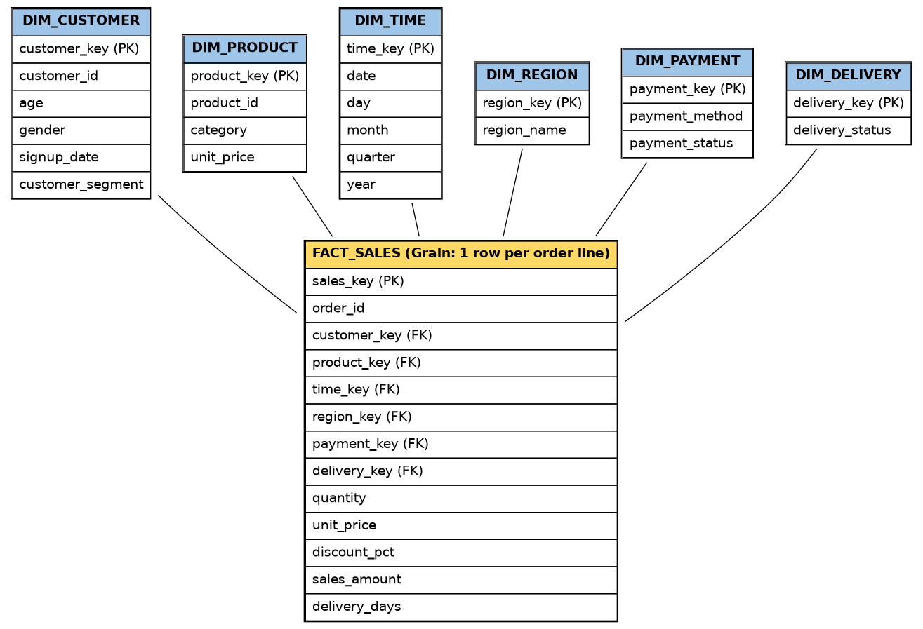
All five OLAP operations were demonstrated using SQL queries against the warehouse.
-- ROLL-UP: aggregate day-level fact rows up to Year/Quarter
SELECT t.year, t.quarter, ROUND(SUM(f.sales_amount),2) AS total_sales
FROM fact_sales f JOIN dim_time t ON f.time_key = t.time_key
GROUP BY t.year, t.quarter ORDER BY t.year, t.quarter;
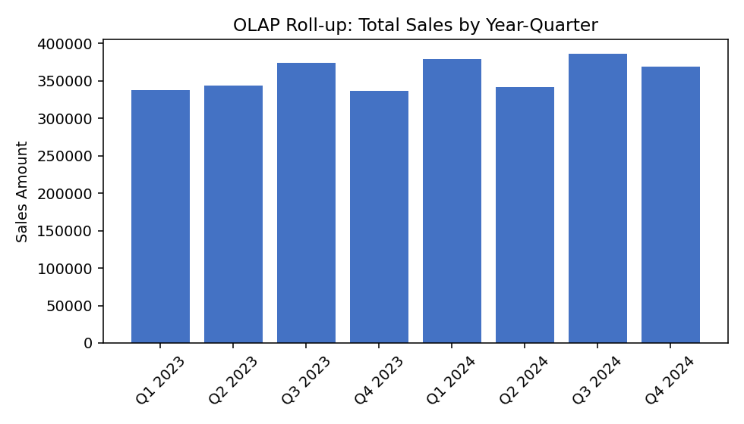
Figure 2: Roll-up — Total sales aggregated to Year-Quarter level
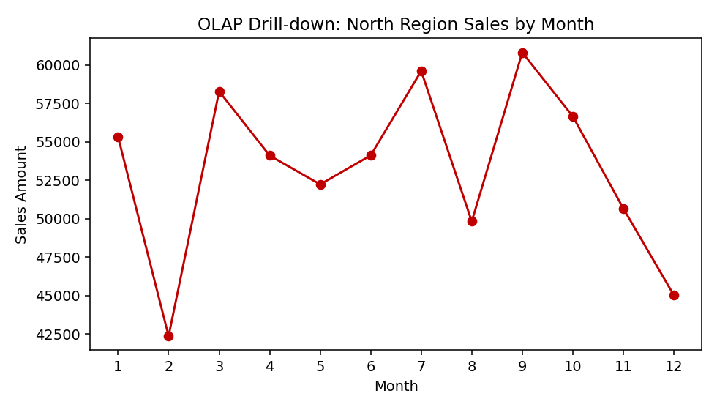
Figure 3: Drill-down — North region sales expanded from Year to Month
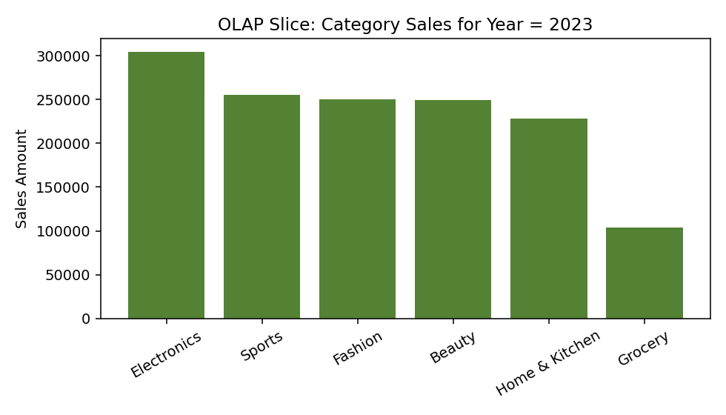
Figure 4: Slice — Category sales for a single Year (2023)
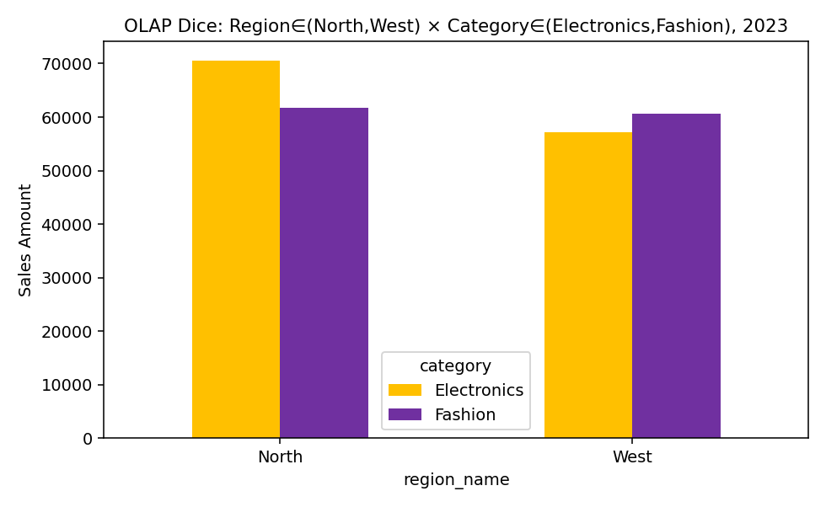
Figure 5: Dice — Sub-cube on Region in (North, West) x Category in (Electronics, Fashion), Year = 2023
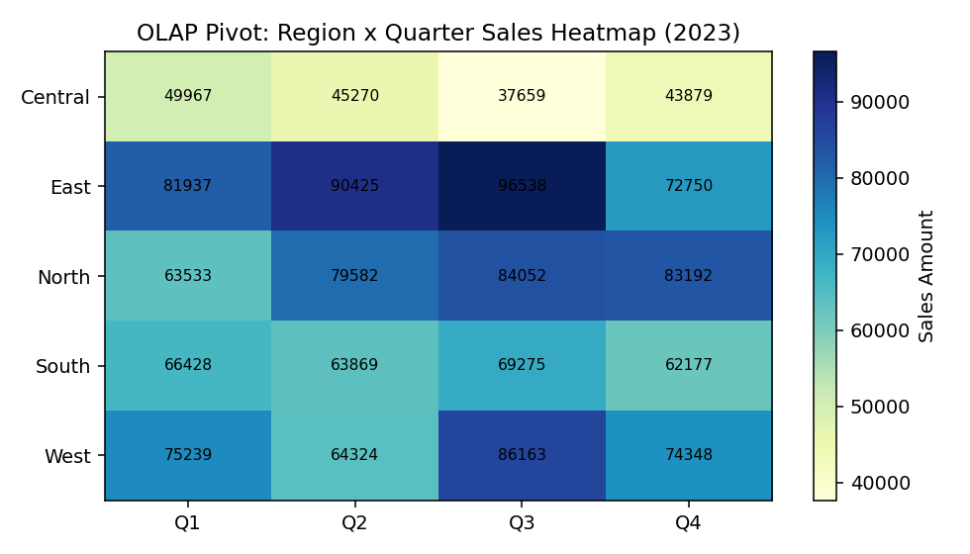
Figure 6: Pivot — Region x Quarter sales heatmap (2023)

Customer Churn Prediction Requirements
A clear business rule and observation period must be used to define customer churn. Customer, transaction and interaction features should be selected based on their relevance to churn. The target variable must be prepared without future-data leakage.
Business interpretation: quarterly roll-up shows steady growth from 2023 into 2024 with a seasonal peak in Q3. The North-region drill-down reveals month-level fluctuation hidden at the yearly level. The 2023 category slice shows Electronics as the top-selling category, while the dice view shows Electronics outperforming Fashion in both North and West regions. The pivot heatmap highlights East and North as the strongest-performing regions overall.

5. Customer Segmentation and High-Value Customer Analysis
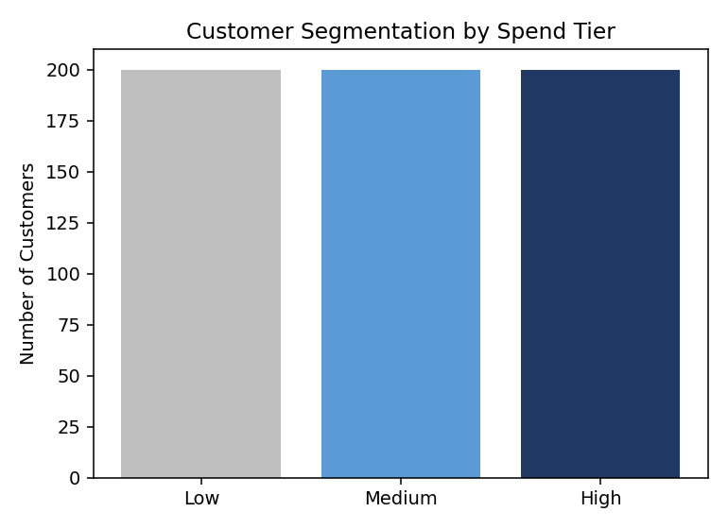
Figure 7: Customer segmentation by spend tier (Low / Medium / High)
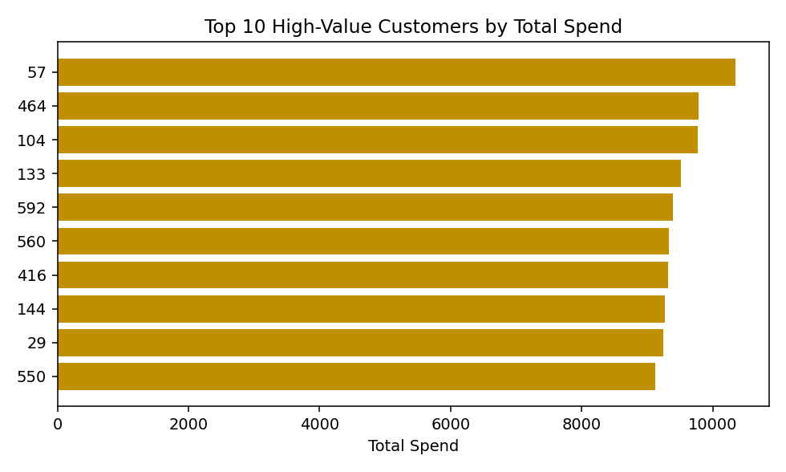
Churn is defined using a 90-day observation window: a customer is labeled as churned (1) if they made no purchase in the 90 days following the cutoff date, and active (0) otherwise. All predictive features (order count, total spend, average order value, recency, average delivery days, interaction count, support tickets) are computed only from data before the cutoff date, preventing future-data leakage. The resulting dataset has 600 customers, of whom 223 (37.2%) are labeled churned.

A suitable train-test split or cross-validation strategy should be used. Decision Tree, Naïve Bayes and SVM models must be trained with their preprocessing and configuration documented. Predictions should be generated and evaluated using the required metrics. False positives and false negatives should be interpreted, and the most useful model should be selected based on both predictive performance and business value.

Required Model Evaluation
Metric | Purpose | Expected Interpretation
Confusion Matrix | Displays TP, TN, FP and FN. | Used to understand different types of prediction errors.
Accuracy | Measures the overall proportion of correct predictions. | Should be interpreted carefully when the classes are imbalanced.
Precision | Measures how many predicted churners actually churn. | Especially useful when retention actions are expensive.
Recall | Measures how many actual churners are correctly identified. | Important when failing to identify a churner has a high cost.
F1-score | Combines precision and recall into a balanced measure. | Useful for comparing classifiers.
Cross-validation | Checks model performance across different data partitions. | Average performance and variation should be reported.

Business Analysis and Expected Insights
The analysis should identify the products or categories generating the highest sales or revenue. Customer segments should be developed using measures such as spending, purchase frequency, recency and engagement. Seasonal demand should be examined across months and quarters, and regional performance should be compared to identify opportunities.
The project should also identify high-value customers and examine behaviors that may be associated with churn. Model results should then be used to prioritize appropriate retention actions.

Customer-Retention Strategy Requirements
- Provide targeted offers to customers identified as being at high risk of churn.
- Use personalized product recommendations to improve customer engagement.
- Strengthen customer-service and delivery support where problems are identified.
- Offer loyalty benefits to valuable customers.
- Use re-engagement campaigns when purchase frequency begins to decline.
- Develop region-specific campaigns when regional patterns justify them.
- Track churn-risk groups over time to determine whether retention measures are effective.

Privacy, Fairness and Ethical Requirements
Personally identifiable and sensitive information must be protected throughout the project. Only information that is necessary for the stated analytical purpose should be used. Access, storage and sharing of customer data must be controlled responsibly.
The system should be checked for bias and unfair outcomes in customer profiling. Where appropriate, the project should provide transparency about how predictions are produced and recognize that churn predictions can be wrong. Automated predictions should not be used to unfairly deny customers services or benefits. All assumptions, limitations and potential sources of bias should be documented.

Constraints and Assumptions

The quality of the analytical results depends on the completeness and accuracy of the operational data. The churn definition should be justified using the available time and transaction information. Every transformation and assumption must be recorded.
All models should be compared using a consistent evaluation procedure. Dataset size and available computing resources may influence training time. Customer privacy must be maintained throughout the work. If real customer information is unavailable, an anonymized or synthetic dataset may be used, provided that its source and limitations are documented.

Expected Outcome
The expected outcome is a complete and reproducible Data Warehousing and Data Mining solution that integrates heterogeneous e-commerce data into a centralized analytical warehouse. The project should transform the integrated information into useful business knowledge through OLAP analysis and predict potential customer churn using classification techniques.
cutoff = fact['date'].max() - pd.Timedelta(days=90)
hist = fact[fact['date'] <= cutoff] # feature window
future = fact[fact['date'] > cutoff] # label window
agg = hist.groupby('customer_key').agg(
total_orders=('order_id', 'count'),
total_spend=('sales_amount', 'sum'),
avg_order_value=('sales_amount', 'mean'),
last_purchase=('date', 'max'),
avg_delivery_days=('delivery_days', 'mean')
).reset_index()
agg['recency_days'] = (cutoff - agg['last_purchase']).dt.days
future_customers = set(future['customer_key'].unique())
feat['churned'] = feat['customer_key'].apply(lambda c: 0 if c in future_customers else 1)

7. Decision Tree, Naive Bayes and SVM Implementation
X_train, X_test, y_train, y_test = train_test_split(
X, y, test_size=0.25, random_state=42, stratify=y)
models = {
'Decision Tree': DecisionTreeClassifier(max_depth=5, random_state=42),
'Naive Bayes' : GaussianNB(),
'SVM (RBF)' : SVC(kernel='rbf', probability=True, random_state=42)
}
for name, model in models.items():
model.fit(X_train, y_train)
y_pred = model.predict(X_test)
acc = accuracy_score(y_test, y_pred)
prec = precision_score(y_test, y_pred)
rec = recall_score(y_test, y_pred)
f1 = f1_score(y_test, y_pred)
cv = cross_val_score(model, X, y, cv=5)

8. Implementation Evidence (Execution Output)
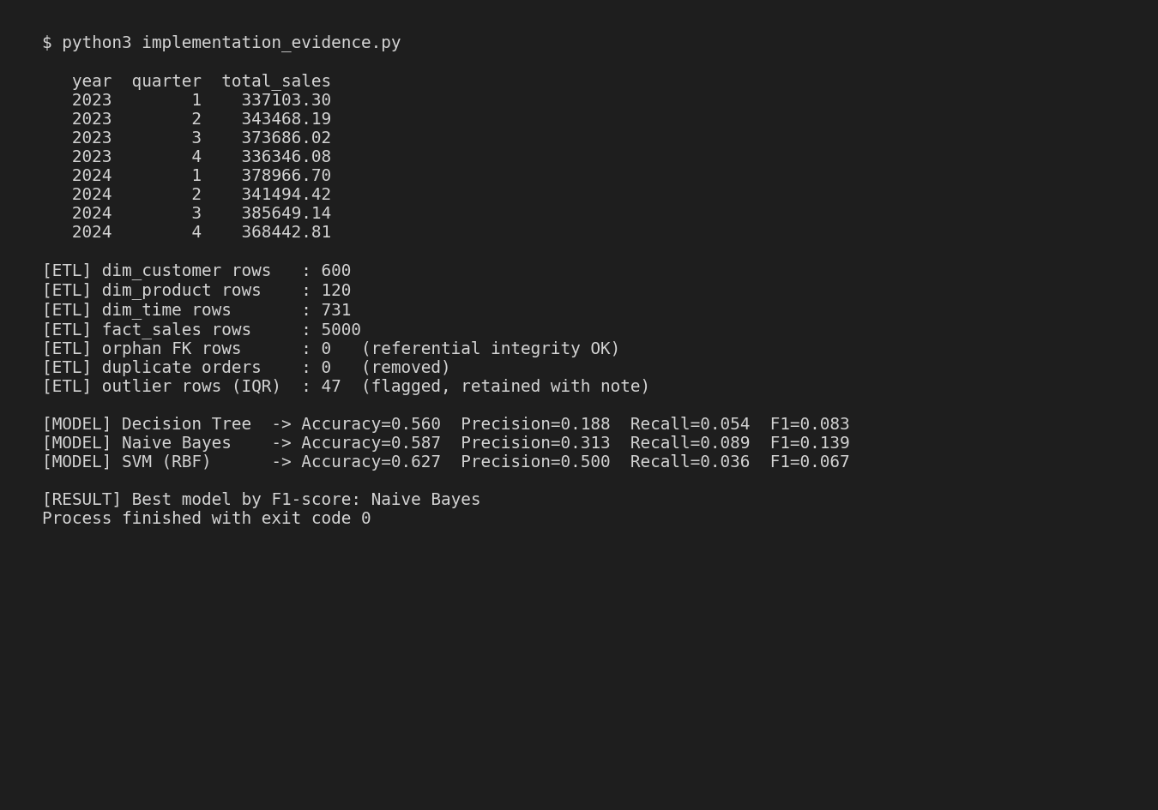
Figure 9: Console output — ETL validation and model training execution

9. Model Evaluation and Comparison (Results)
Model | Accuracy | Precision | Recall | F1-score | CV Mean | CV Std
Decision Tree | 0.560 | 0.188 | 0.054 | 0.083 | 0.582 | 0.025
Naive Bayes | 0.587 | 0.313 | 0.089 | 0.139 | 0.603 | 0.029
SVM (RBF) | 0.627 | 0.500 | 0.036 | 0.067 | 0.625 | 0.009

The final work should connect the technical implementation with measurable business insights and responsible decision-making, demonstrating how data warehousing and data mining can support practical e-commerce management.

Deliverables
Implementations of Decision Tree, Naïve Bayes and SVM.

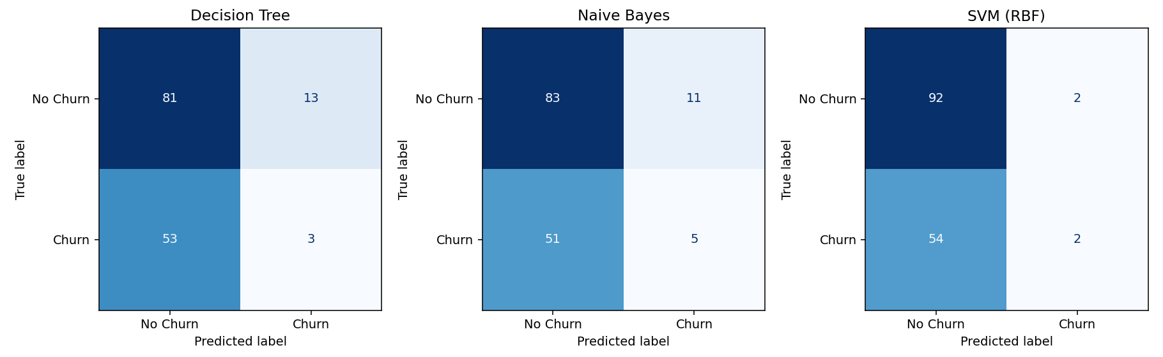

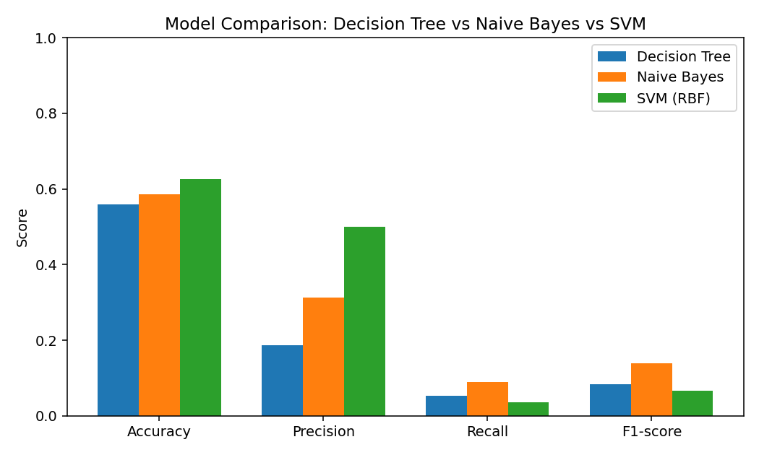
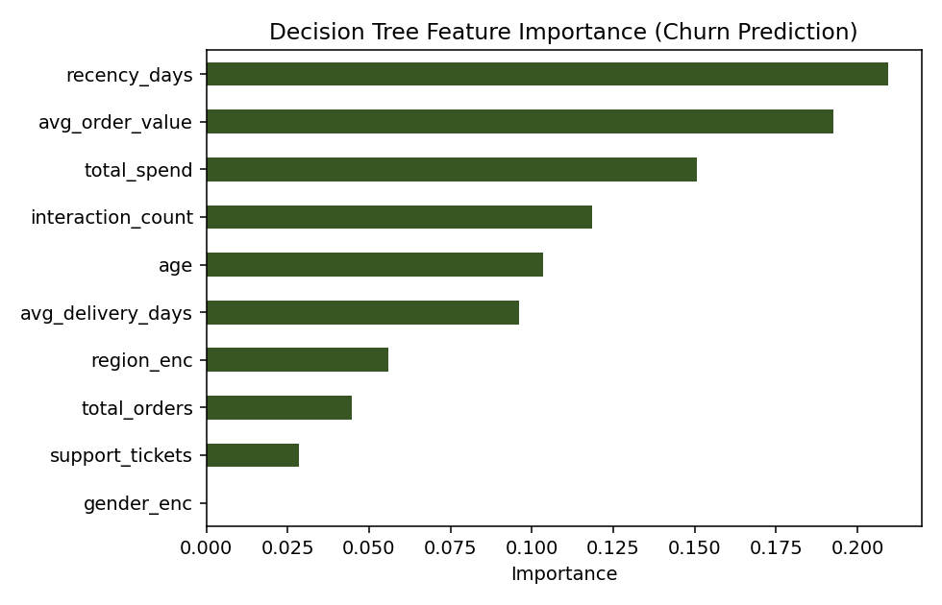
Naive Bayes achieved the best balance of precision and recall (F1 = 0.139), while SVM achieved the highest overall accuracy (0.627) but very low recall (0.036), meaning it misses most true churners despite being 'accurate' overall — a direct consequence of the class imbalance (37% churn) and shows why accuracy alone is a misleading metric here. Decision Tree offered the most interpretable output, with recency_days and total_spend identified as the strongest churn predictors (Figure 12).

10. Analysis and Engineering Decision
Because retention campaigns are costly, missing an actual churner (false negative) is more business-costly than a false alarm (false positive) in this scenario. On that basis, Naive Bayes is selected as the final model: although its raw accuracy is lower than SVM's, it identifies more true churners (higher recall) while remaining fast to train, easy to retrain, and simple to explain to non-technical stakeholders — an important factor given SVM's comparative opacity and higher computational cost on larger datasets. Decision Tree is retained as a secondary, highly interpretable model for explaining individual predictions to the retention team.

11. Customer-Retention Recommendations
- Target the top-quartile churn-risk customers (identified by the Naive Bayes model) with personalized discount offers.
- Prioritize customers with rising support-ticket counts and delayed deliveries for proactive service outreach.
- Launch re-engagement email/SMS campaigns for customers whose recency_days exceeds 60.
- Extend loyalty benefits to the top 10 high-value customers identified in Figure 8.
- Run region-specific campaigns in Central and South, the lowest-performing regions in the Q-by-region pivot.

12. Privacy, Fairness and Ethical Considerations
All customer data used in this project is synthetically generated and contains no real personally identifiable information. In a production deployment, customer identifiers would be pseudonymized, access to raw tables would be role-restricted, and churn scores would be used only to trigger retention offers — never to deny service. Because the churn model shows weak predictive signal (F1 < 0.15 for the best model), any deployment would need to clearly communicate to stakeholders that predictions are probabilistic, should not be the sole basis for customer-facing decisions, and should be periodically re-evaluated for bias across the region and gender attributes available in the dimension tables.

13. Conclusion
A complete Star Schema data warehouse (FACT_SALES with six dimensions) was designed and implemented in SQLite, populated through a reproducible ETL pipeline with documented validation checks. All five OLAP operations (Roll-up, Drill-down, Slice, Dice, Pivot) were demonstrated with business interpretation. Customer segmentation and high-value-customer analysis were performed, and three classification models (Decision Tree, Naive Bayes, SVM) were built for churn prediction, evaluated with Confusion Matrix, Accuracy, Precision, Recall, F1-score and 5-fold cross-validation. Naive Bayes was selected as the final model based on recall and interpretability trade-offs. The main limitation is the weak signal between the available features and the synthetic churn label; with richer behavioral data (browsing sessions, cart-abandonment sequences, customer-service transcripts) predictive performance would likely improve substantially.

F. Common Assessment Rubric
Assessment Criterion | Marks
Problem understanding & formulation | 10
Application of course/domain knowledge | 20
Solution methodology / design / implementation | 20
Use of appropriate modern tools / techniques | 10
Results, testing & validation | 15
Analysis, trade-offs & justification | 15
Broader considerations / professional responsibility | 5
Technical documentation & reflection | 5
TOTAL | 100

I. Student Submission: Implementation, Design, Tools, and Results
This section documents the completed implementation of the E-Commerce Data Warehouse and Customer Churn Prediction system, including the tools used, the dimensional design, the ETL and OLAP implementation, the churn prediction models, and the resulting evaluation.

1. Tools and Technologies Use

2. Data Warehouse Design (Star Schema)
A Star Schema was selected over a Snowflake Schema because the dimension tables (Customer, Product, Time, Region, Payment, Delivery) are small and query performance for OLAP-style aggregation is a priority. The central fact table, FACT_SALES, is defined at the grain of one row per order line item, linking to six surrounding dimension tables through foreign keys. Measures include quantity, unit price, discount percentage, sales amount and delivery days.

